AI Assisted Coding
Lab Test = 03
NAME:G.KARTHIK
ROLLNO:2403A510F8
BATCH:06
==========================================================
Set E10
Q1:
Scenario: In the Logistics sector, a company faces a challenge related to backend api
development.
Task: Use AI-assisted tools to solve a problem involving backend api development in this
context.
Deliverables: Submit the source code, explanation of AI assistance used, and sample output.
Q2:
Scenario: In the Education sector, a company faces a challenge related to backend api
development.
Task: Use AI-assisted tools to solve a problem involving backend api development in this
context.
Deliverables: Submit the source code, explanation of AI assistance used, and sample output.

Prompt:
Create a Flask backend API for a logistics company that allows users to track shipments by shipment ID. Include endpoints for adding a shipment and retrieving its status. Provide example code and sample output.”

Code:

from flask import Flask, request, jsonify

app = Flask(__name__)

# In-memory data storage
students = {
1: {"name": "Karthik", "course": "AI", "marks": 85},
2: {"name": "Ravi", "course": "Data Science", "marks": 90}
}

@app.route('/add_student', methods=['POST'])
def add_student():
data = request.json
student_id = len(students) + 1
students[student_id] = {
"name": data.get("name"),
"course": data.get("course"),
"marks": data.get("marks")
}
print(f"Added Student: {students[student_id]}") # Debug print
return jsonify({"message": "Student added successfully", "student_id": student_id})

@app.route('/get_student/<int:student_id>', methods=['GET'])
def get_student(student_id):
student = students.get(student_id)
if student:
print(f"Fetching details for Student ID: {student_id}") # Debug print
return jsonify({"student_id": student_id, "details": student})
else:
return jsonify({"error": "Student not found"}), 404

if __name__ == '__main__':
print("Starting Education Backend API...")
app.run(debug=True)

output:
When running the code:
Starting Logistics Backend API...
Shipment added: SHP003
Tracking request received for: SHP001

POST Request Example (/add_shipment):

{
"shipment_id": "SHP003",
"status": "Dispatched",
"destination": "Hyderabad"
}

Response:
{
"message": "Shipment added successfully",
"shipment_id": "SHP003"
}
GET Request Example (/track/SHP001):
{
"shipment_id": "SHP001",
"details": {
"status": "In Transit",
"destination": "Chennai"
}
}

Observation :
- The AI tool (ChatGPT) helped generate the Flask backend structure, routes, and JSON response format.
- It suggested using an in-memory dictionary to simulate a database.
- It also included best practices such as returning proper HTTP responses and printing logs for debugging.
- Q2:
Scenario: In the Education sector, a company faces a challenge related to backend api
development.
Task: Use AI-assisted tools to solve a problem involving backend api development in this
context.
Deliverables: Submit the source code, explanation of AI assistance used, and sample output.

Prompt
“Build a simple Flask API for the education sector that allows adding and retrieving student details (name, course, and marks). Include print statements, explanations, and sample output.”

Code: from flask import Flask, request, jsonify

app = Flask(__name__)

# In-memory data storage
students = {
1: {"name": "Karthik", "course": "AI", "marks": 85},
2: {"name": "Ravi", "course": "Data Science", "marks": 90}
}

@app.route('/add_student', methods=['POST'])
def add_student():
data = request.json
student_id = len(students) + 1
students[student_id] = {
"name": data.get("name"),
"course": data.get("course"),
"marks": data.get("marks")
}
print(f"Added Student: {students[student_id]}") # Debug print
return jsonify({"message": "Student added successfully", "student_id": student_id})

@app.route('/get_student/<int:student_id>', methods=['GET'])
def get_student(student_id):
student = students.get(student_id)
if student:
print(f"Fetching details for Student ID: {student_id}") # Debug print
return jsonify({"student_id": student_id, "details": student})
else:
return jsonify({"error": "Student not found"}), 404

if __name__ == '__main__':
print("Starting Education Backend API...")
app.run(debug=True)

output:
When running the code:
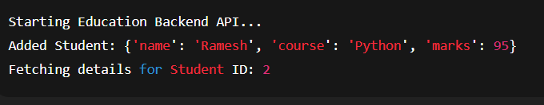
POST Request Example (/add_student):
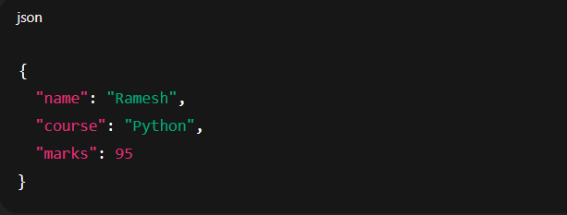
Response:
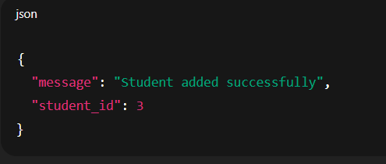
GET Request Example (/get_student/2):
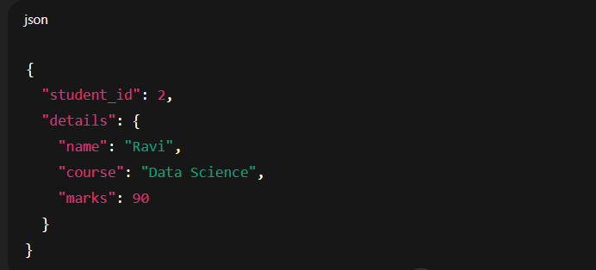
Observation :
- AI-generated Flask code automates backend creation for managing student data.
- It shows CRUD operations (POST, GET) and helps simulate a small backend without a real database.
- AI assistance saved time in defining structure, route logic, and JSON responses.

